**An Art Historical Analysis of Travelling Chocolate Service**

Artwork can reflect the evolution of society, and the artworks of the European period are closely related to the social and cultural context of that time. For instance, lots of the culture and art business was based on entertainment and invention during the eighteenth century, and Mimi Hellman points out a significant idea of the object-as-narrator which can prove the important role of decorative artworks in the social life of eighteenth-century France.[1] Exploring the artwork named Travelling Chocolate Service ***[Figure1]*** may provide a unique understanding of the lifestyle of the eighteenth-century French.

This travelling chocolate service is one kind of Nécessaire de voyage. It is composed of two main components, the first part is a storage box with a drawer, it is mainly made of wood, the exterior is wrapped with red leather, and some brass parts on the surface like hinges, handles, locks, and keys. The interiors are covered by blue fabric with elaborate gold stitching. The other part is a set of chocolate-making tools and tableware: a porcelain mug with a lid, a pair of porcelain mugs and plates to match, a pair of glasses with lids, a silver jug with a wooden handle, three silver spoons, and a set of knives and forks with ceramic handles. As a typical travel set, those dishes and tools are compactly placed in individual compartments. The lock is designed to keep storage private and secure.

This travel set was produced in 1765 and contains a variety of materials and techniques such as porcelain, silver, glass and wood. The porcelain sections were produced by the Mennecy Porcelain Factory and other silvers were made by two silversmiths, François Joubert and Louis Samson II.[2] Mennecy porcelain factory was established under the patronage of Louis-François-Anne de Neufville, duc de Villeroy (1695–1766), and specialised in French soft-paste porcelain.[3] ***[Figure2]*** This type of porcelain has a smooth surface and a light texture. The pieces for chocolate are decorated with 3D flower patterns and not painted. Those production of tableware is very rarely seen in the Mennecy factory, which mainly makes small figures and colourful decorations. Partly because the Vincennes gained a monopoly power in tableware production in 1745. [4] The other pieces like glass and silver are more on function and portable features, due to the consideration of the special need of Nécessaire de Voyage.

Nécessaire de Voyage is a specialized type of box made for travelling and contains the necessary items for the trip. It originally developed at the end of the 14th century and gained popularity in the 18th century. During the reign of Louis XV, Travelling and excursions around the world became a respected educational concept and a popular pleasure for young aristocrats.[5] Also, the demand for travel boxes expanded during that period, and the purpose of the travel boxes has also evolved from simple cosmetic functions like shaving ***[Figure 3]*** and grooming ***[Figure 4]*** to a diversified use.***[Figure 5]*** Generally, those boxes will be customized according to the purchaser’s personal tastes and requirements.[6] In the luxury stores of Paris, customized items are usually expensive by several times compared to mass-produced products.[7] In that case, those beautiful and expensive boxes also can fully reflect the wealth and social status of their owners, and then turning into a status symbol.[8]

The Nécessaire de Voyage is named Travelling Chocolate Service for making chocolate and contains the tools. In this particular era, chocolate is likewise a status symbol. Chocolate was imported from Spanish to French in the mid-sixteenth century.[9] Then it became popular in wealthy social circles in the following decades. In the eighteen-centuries, chocolate became a significant part of French culture, but the production process was complex, and manufacturers were quite few, chocolate was expensive at that time. As a result, the use of authentic chocolates is mainly among the rich people. [10] The pursuit of luxury has led to a new trend of consumption and stimulated a significant transformation of production resources.[11]

Generally, the production of these boxes requires collaboration across multiple industries, such as porcelain factories, gold and silver making, cabinetmaking, etc.[12] Thus, some craftsmen cooperated, and their objects were put together and sold as a whole to meet the diverse needs of the wealthy class. Such a mode of design and sale was very prevalent in the eighteenth century and was attributed to the important role of marchands-merciers in the transformation of products. Marchands-merciers are not permitted to make objects, but can provide design ideas and assist or commission artisans to make complex items across categories.[13] These merchants served the elite class and became the bridge between craftsman’s production and the elite’s demand, to some extent altering the cultural connotations of decoration. With this creative production method, marchands-merciers were seen as having a higher social status than artisans.[14]

In summary, Travelling Chocolate Service as a kind of Nécessaire de Voyage is made for the requirements of the wealthy class and elites of 18th century France in terms of travel, refined chocolate, and status symbols. From a commercial perspective, it is an example of converting ordinary handmade items into luxury products that emphasize refined taste and social attributes, which means that those luxurious travel boxes were more collectible than just functional and were usually owned by the elites and wealthy class that had a refined lifestyle.

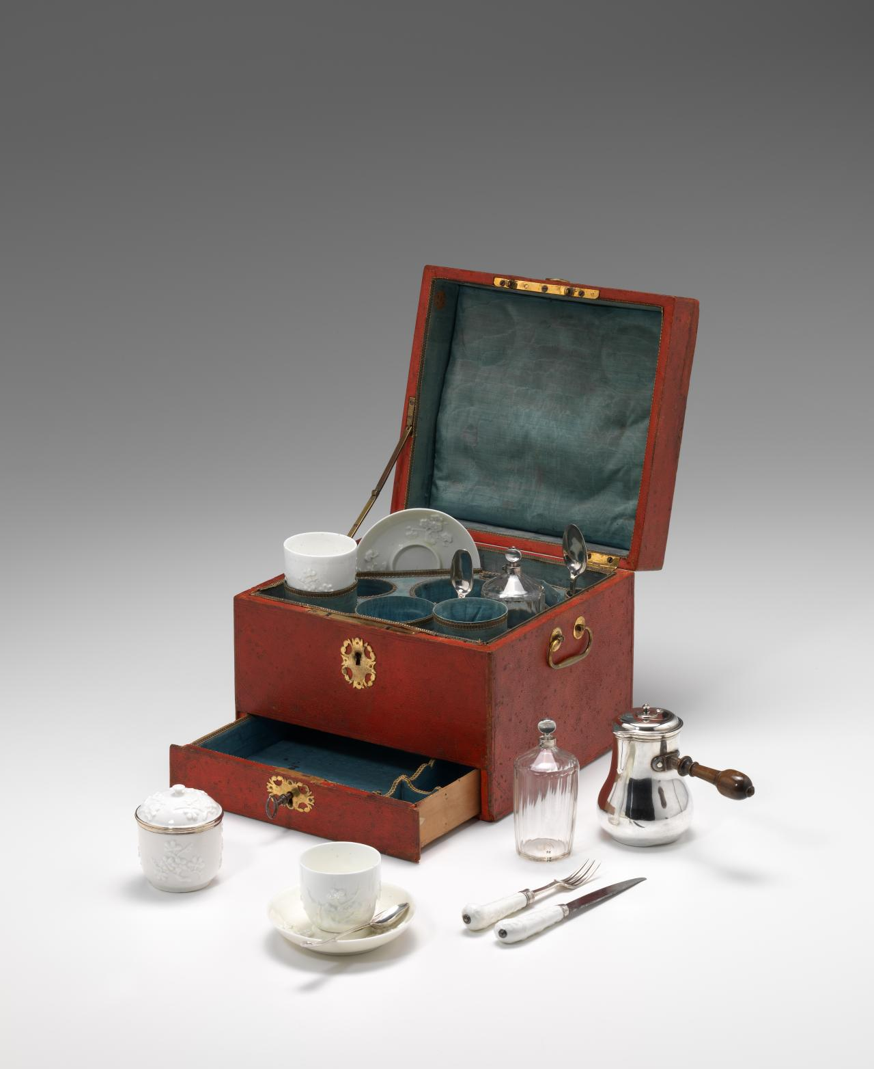

Figure 1: Travelling chocolate service (1765)

Manufacturer: Mennecy, François JOUBERT (silversmith) Louis SAMSON II (silversmith)

Medium: porcelain, glass, silver, leather, wood, brass, other materials

National Gallery of Victoria, Melbourne

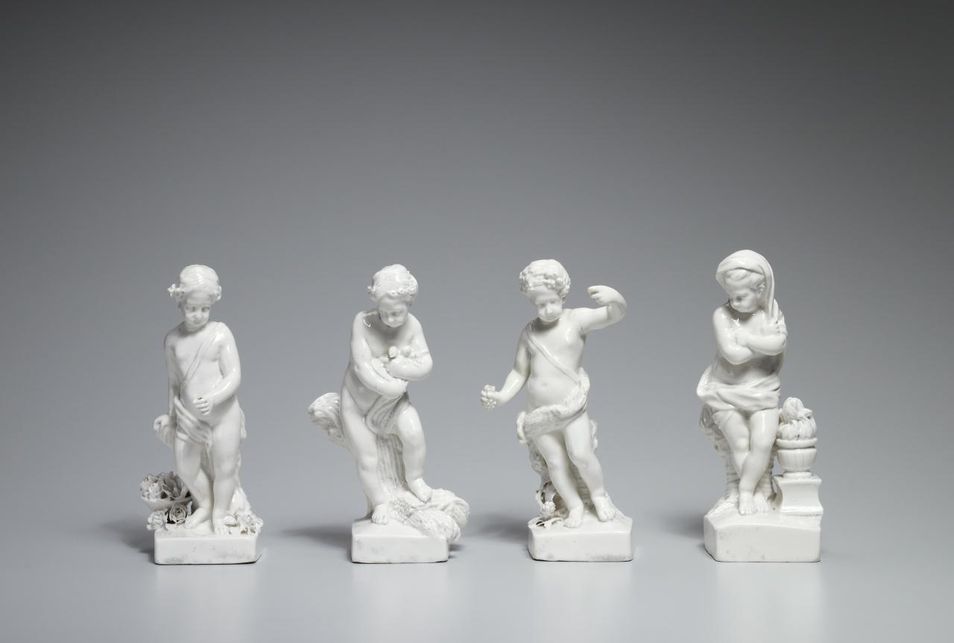

Figure 2: The Four Seasons (1770)

Manufacturer: Mennecy

Size: (1) 17.8 × 7.8 × 8.8 cm (spring)

(2) 17.8 × 9.8 × 7.8 cm (summer)

(3) 17.8 × 9.2 × 7.9 cm (autumn)

(4) 18.4 × 7.4 × 6.2 cm (winter)

Medium: porcelain (soft-paste)

National Gallery of Victoria, Melbourne

Figure 3: Traveling Shaving Tools (18th century)

Size: 1.8" *1.5" * 0.75"

Figure 4: Magnificent Antique Dressing Cabinet from Asprey (1851)

Figure 5: An array of must-haves for the fashionable traveller (1815)

Size: 6.5" * 17" *11.75"

Medium: porcelain, glass, silver, leather, wood, brass, other materials

Bibliography

Berg, M. 2004. “In Pursuit of Luxury: Global History and British Consumer Goods in the Eighteenth Century.” *Past & Present*182 (1): 85–142. <https://doi.org/10.1093/past/182.1.85>.

This author mentions the consumer society and production relations, which can explain the influence of luxuries. It also compares the different centuries of consumer habits and trends. When discussing the European and France consumer societies, some basic information about the background comes from this article.

Gordon, Bertram M. 2008. “Chocolate in France.” *Chocolate*, May, 569–82. <https://doi.org/10.1002/9780470411315.ch42>.

Gordon describes the history of chocolate in France. According to the author, chocolate as an imported beverage is very expensive and difficult to produce. In that case, the use of chocolate is mainly relied on nobles and the wealthy class.

Hellman, Mimi. 1999. “Furniture, Sociability, and the Work of Leisure in Eighteenth-Century France.” *Eighteenth-Century Studies* 32 (4): 415–45. <https://www.jstor.org/stable/30053926>.

This article’s author discusses the relationship between furniture, sociability, and leisure work. In 18th-century France, the lifestyle of the elites has changed a lot. The most contributing part is the information about the marchands-merciers in France, this article contains the statues of this group, details of their work and the relationship with the craftsman and wealthy class.

Liechtenhan, Francine-Dominique, and Alain Guyot. 2018. “Partir : Pour Quoi Faire ? De Quelques ‘Méthodes’ et ‘Arts de Voyager’ Aux Xvie et Xviie Siècles.” *Viatica*, no. 5 (April). <https://doi.org/10.52497/viatica984>.

When I explored the history and development of travel in France, this article explained a lot about the thoughts and trends in different centuries. Which help me find out the lifestyle of the travel in the wealthy class.

Lucian, Daniel, and Copyright Daniel Lucian. 2012. “History of Dressing Cases.” Antique Box Guide. May 24, 2012. <https://www.antiquebox.org/history-of-dressing-cases>.

This website provides the history of the Nécessaire de voyage which is necessary for introducing the object. Moreover, it also showed me some different kinds of travel set with their specific functions.

“Mennecy-Villeroy Porcelain.” 2022. Wikipedia. June 20, 2022. <https://en.wikipedia.org/wiki/Mennecy-Villeroy_porcelain#cite_note-13>.

This website is more about fundamental knowledge, this website introduces the history of the Mennecy Porcelain Factory and the features of French soft-paste porcelain.

“The Essentials of Nécessaires de Voyage.” n.d. M.S. Rau. <https://rauantiques.com/blogs/canvases-carats-and-curiosities/essentials-necessaires-de-voyage>.

Most of the images are from this website, this website outlines the type of Nécessaires de Voyage with many pictures which is easy to understand. For instance, the travel set for shaving and grooming. It is necessary to explain the change of the functions.

Verlet, Pierre. 1958. “Le Commerce Des Objets d’Art et Les Marchands Merciers: à Paris Au XVIIIe Siècle.” *Annales. Histoire, Sciences Sociales* 13 (1): 10–29. <https://www.jstor.org/stable/27579924>.

This article also helped me understand the marchands-merciers to some extent. And focuses on more specific details such as luxury prices, consumer behaviour and preferences. Although there are not many direct quotes from the content in the writing process, it offers an important perspective about sciences socials in an academic way.

“Works | NGV | View Work.” n.d. Www.ngv.vic.gov.au. Accessed March 31, 2024. <https://www.ngv.vic.gov.au/explore/collection/work/103300>.

This object travelling chocolate service is one of the exhibits in this gallery online. It offers some details about this object such as the year, manufacture, and materials. In addition, this website collected some other works made by Mennecy which can help me analyze the style of their productions.

1. Mimi Hellman, “Furniture, Sociability, and the Work of Leisure in Eighteenth-Century France,” *Eighteenth-Century Studies*, vol. 32, no. 4 (1999): 416, URL: https://www.jstor.org/stable/30053926.
2. “Travelling chocolate service: Nécessaire de voyage,” National Gallery of Victoria, published 2012, https://www.ngv.vic.gov.au/explore/collection/work/103300/.
3. “Mennecy-Villeroy porcelain,” Wikipedia, published June 2022, https://en.wikipedia.org/wiki/Mennecy-Villeroy_porcelain#cite_note-13.
4. “Mennecy-Villeroy porcelain,”
5. Francine-Dominique Liechtenhan, Alain Guyot, “Partir: pour quoi faire,” *Viatica* (May 2018):13-16, URL: https://journals.openedition.org/viatica/984.
6. “The Essential of Nécessaire de Voyage,” Rau antiques, published August 21 2019, https://rauantiques.com/blogs/canvases-carats-and-curiosities/essentials-necessaires-de-voyage.
7. Pierre Verlet, “Le commerce des objets d'art et les marchands merciers: à Paris au XVIIIe siècle,” *Annales,* Histoire, Sciences Sociales, 13e Année, No. 1 (Jan. - Mar. 1958):27
8. Daniel Lucian, “Antique Box Guide,” Antiquebox, published 2024, https://www.antiquebox.org/history-of-dressing-cases/.
9. Bertram M. Gordon, “Chocolate in France: Evolution of a Luxury Product,” *ResearchGate,* Chapter 42 (May 2008):569, DOI: 10.1002/9780470411315.ch42.
10. Bertram M. Gordon, “Chocolate in France: Evolution of a Luxury Product,” 572.
11. Maxine Berg, “In Pursuit of Luxury: Global History and British Consumer Goods in the Eighteenth Century,” *Past & Present,* No. 182 (Feb. 2004):97 URL: https://www.jstor.org/stable/3600806.
12. “Mennecy-Villeroy porcelain,”
13. Mimi Hellman, “Furniture, Sociability, and the Work of Leisure in Eighteenth-Century France,” 418.
14. Mimi Hellman, “Furniture, Sociability, and the Work of Leisure in Eighteenth-Century France,” 419.